CS 255 System Design Document Template

This template lays out all the different sections that you need to complete for Project Two. Each section has guidance to prompt your thinking. You will need to continually reference the interview transcript as you work to make sure that you are addressing your client’s needs. There is no required length for the final document. Instead the goal is to complete each section based on what your client’s needs are. Remove this note when you are finished, and replace all bracketed text with the relevant information.

UML Diagrams

UML Use Case Diagram
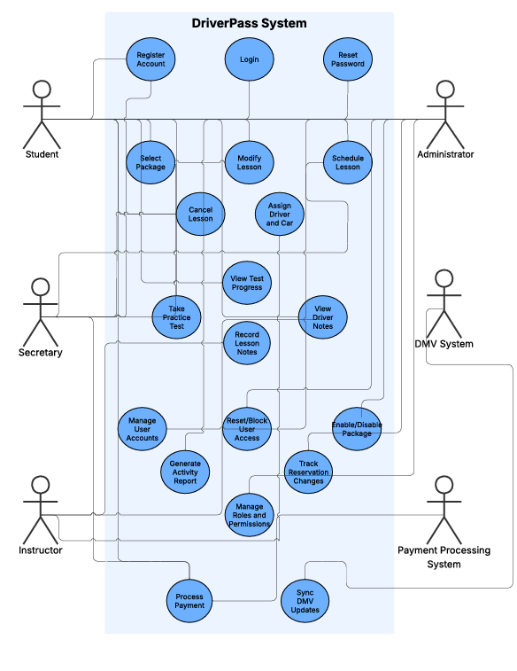

UML Activity Diagrams
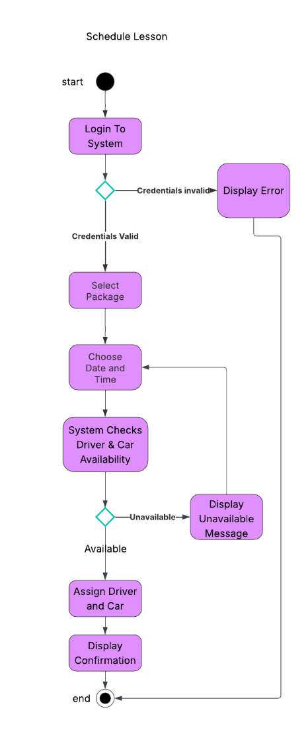
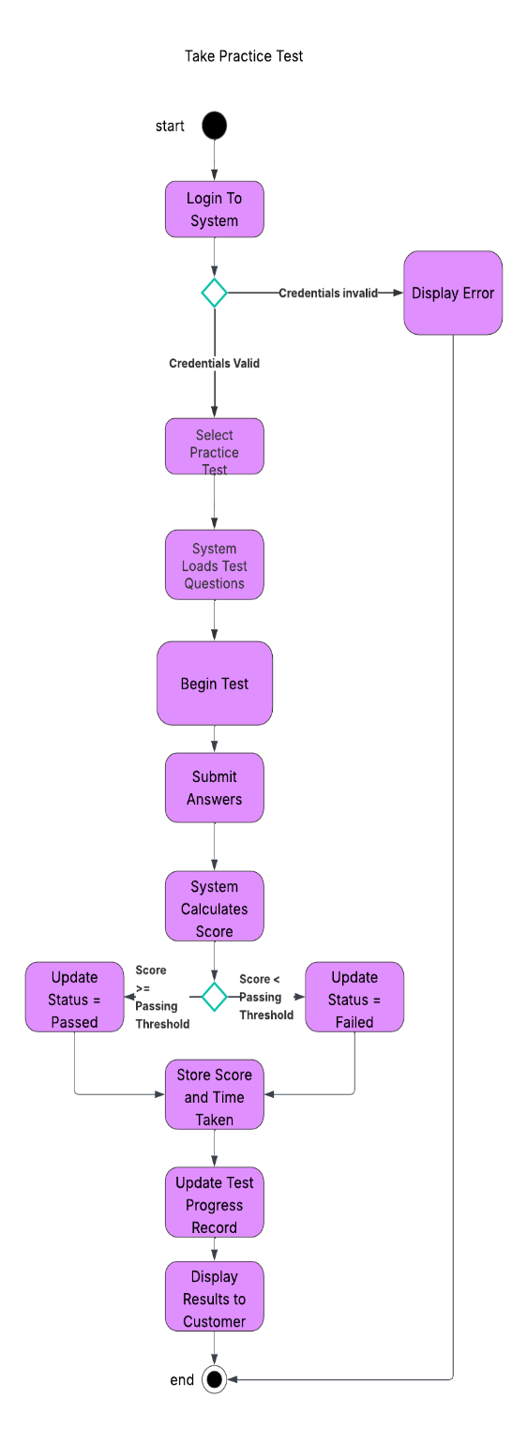

UML Sequence Diagram
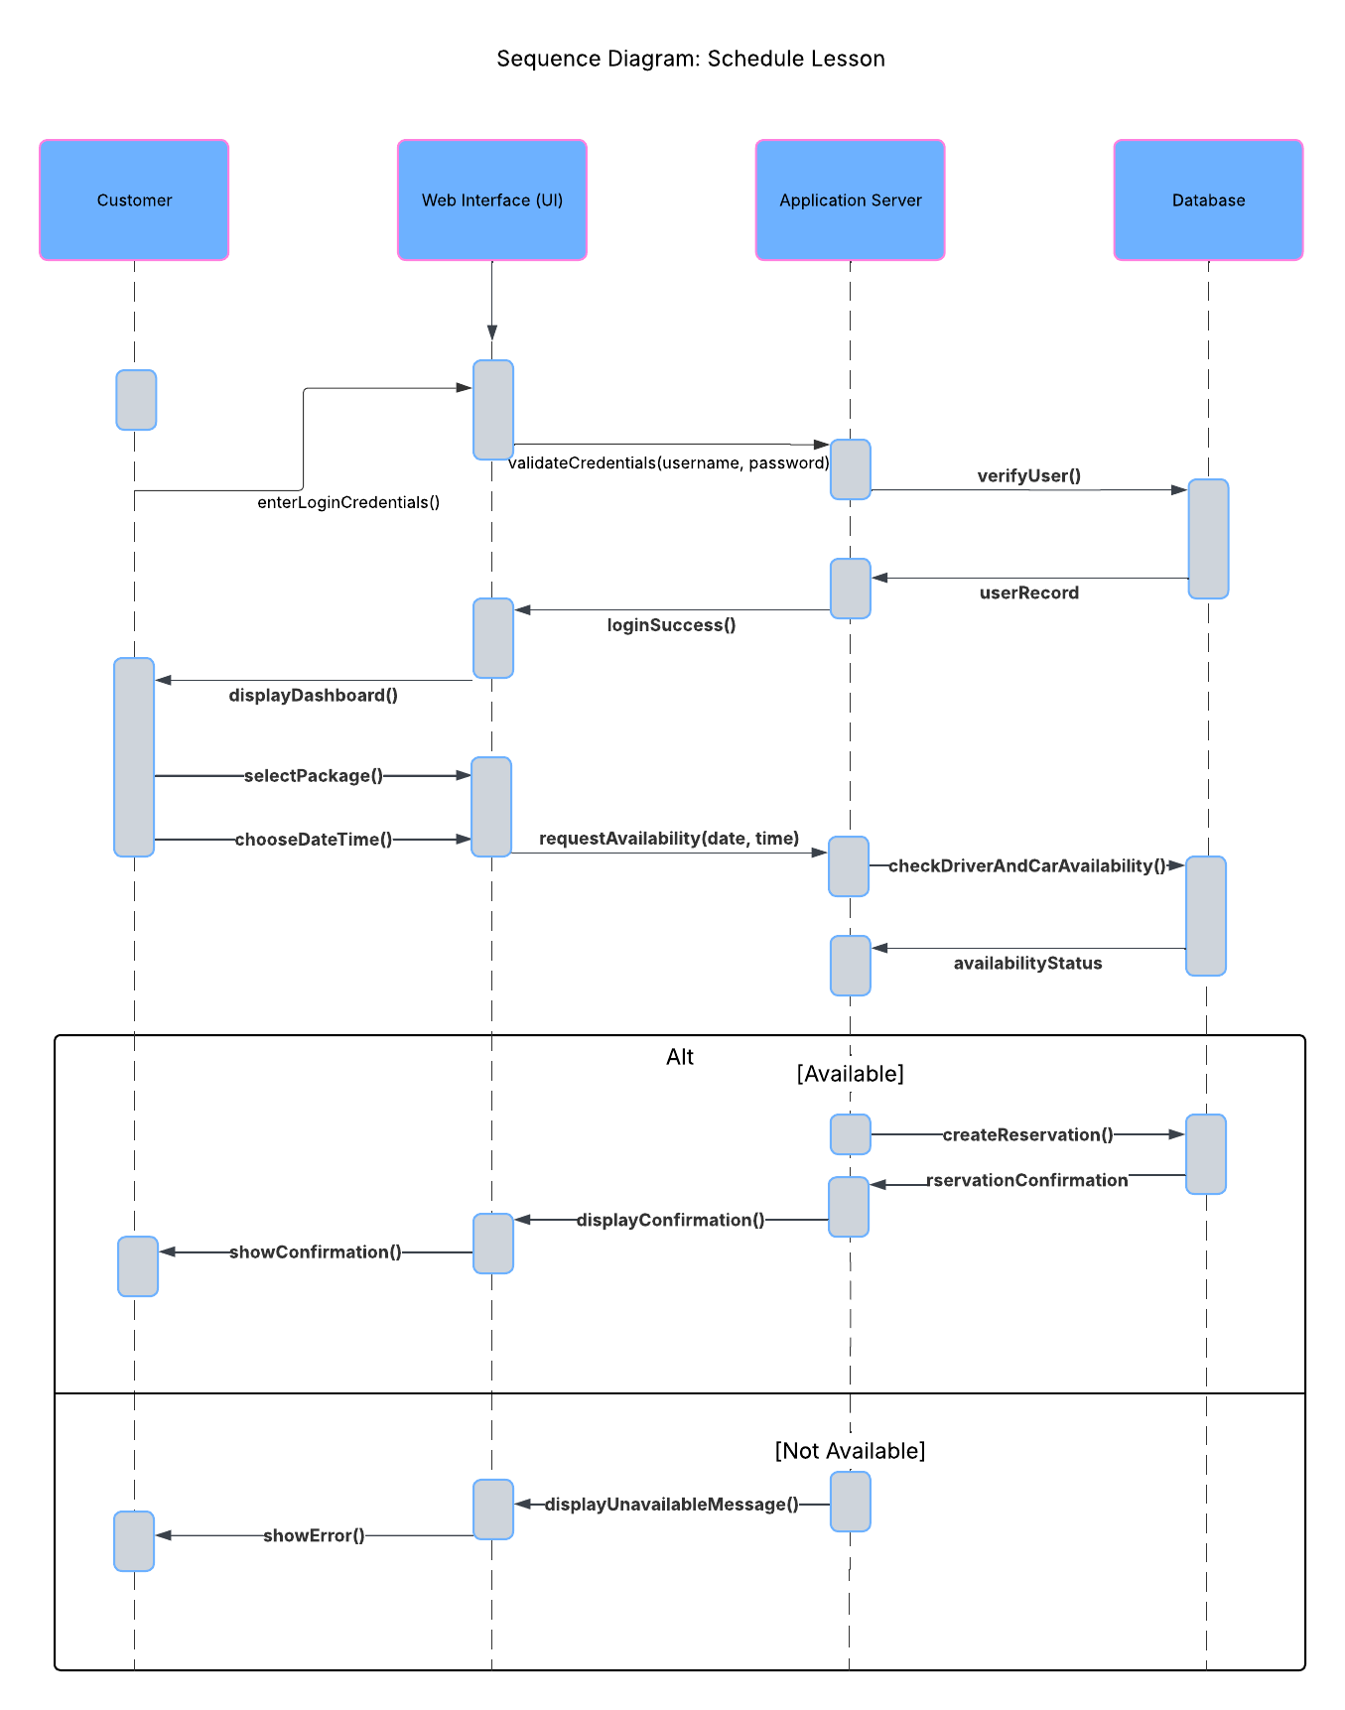

UML Class Diagram
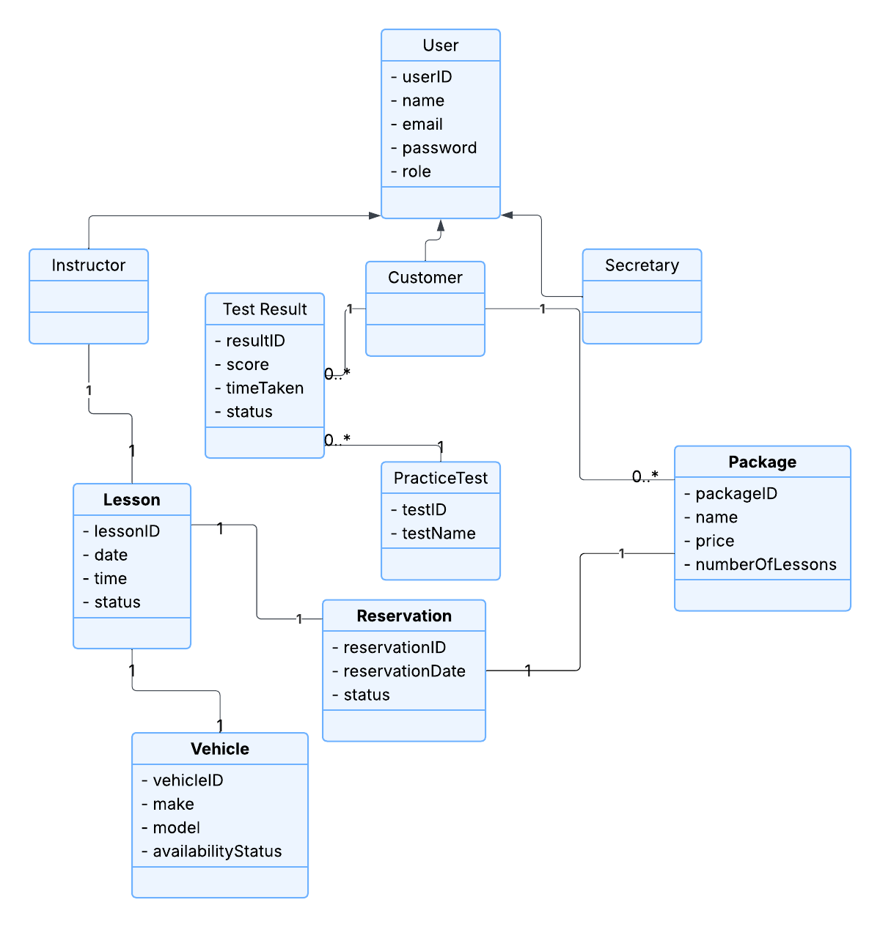

Technical Requirements
DriverPass’s system requires a web-based client-server architecture to support lesson scheduling and practice testing. The system will require standard desktop or mobile devices with internet access for customers, instructors, and administrative staff. On the server side, the system will require a secure web server and application server capable of handling user authentication, scheduling logic, and test scoring functionality. A relational database management system will be required to store user accounts, reservations, lesson details, instructor assignments, vehicles, practice tests, and test results.
The software requirements include a web browser for users, a web application framework to manage business logic, and a database management system to support persistent data storage. Development tools such as UML modeling software were used to design system structure and workflows before implementation.
The infrastructure must support secure internet connectivity, encrypted data transmission, regular database backups, and role-based access control to ensure that only authorized users can access sensitive information. The system must also support scalability to handle increased numbers of users during peak enrollment periods.

